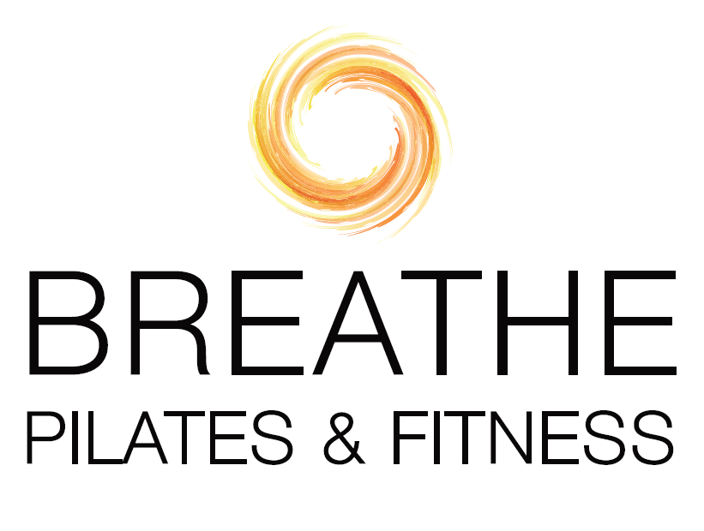
In Studio Pilates Apparatus,
Mat and Strength Training
Pilates Apparatus includes reformers, towers, chairs, barrels, pedipull
and all props. All sessions are customized to your goals, needs,
preferences and schedule.

Private: $95 ($101.03 with tax)
New Client Starter Rate: 3@$255 ($271.20 with tax)
10-sessions: $900 ($957.15)
Duet: $65 per person ($69.13 with tax)
New Client Starter Rate: 3@$165 pp ($175.48 with tax)
6-sessions: $360 pp ($382.86 with tax)
10-sessions: $600 pp ($637.80 with tax)
Groups of 3: $55 per person ($58.50 with tax)
Groups of 4: $50 per person ($53.18 includes tax)

Private ½ hour session: $55 ($58.50 with tax)
Private 45 min. session: $80 ($85.08 with tax)

CT sales tax of 6.35% is added to all studio, virtual and in-person rates (except for if at your home—CT sales tax not required by law). Additional travel fees apply if training to your home or business. Rates are subject to change. Preferred payment options include Zelle, Venmo (@BreathePilatesandFitness) or check (Breathe Pilates or Leslie Berni); PayPal (PayPal.Me/BreatheFitnessLLC) and cash also accepted.

