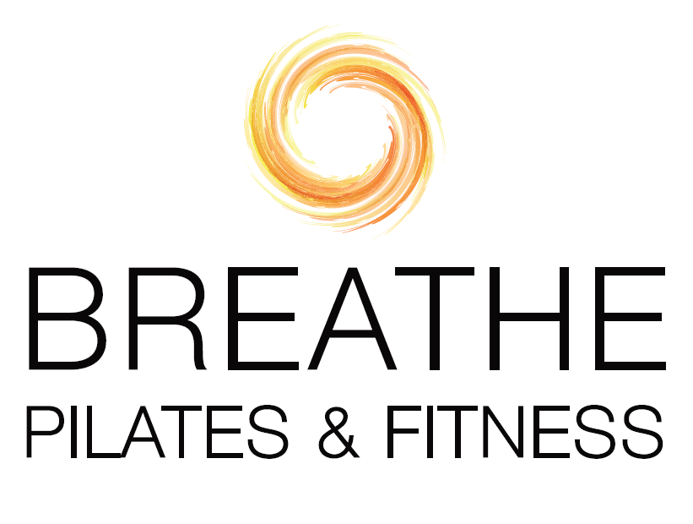

2025 New Client Pricing  
In Studio Pilates Apparatus, Mat and Strength Training  
Pilates Apparatus includes reformers, towers, chairs, barrels, Pedi-pull   
and all props. All sessions are customized to your goals, needs,   
preferences and schedule (all 55 min. unless otherwise stated).

Private: $130 ($138.26 with tax) / Venmo :$140.88

New Client Starter Rate: 3 for $330 ($351 with tax) / Venmo: $357.62  
10-sessions: $1200 ($1276.20 with tax) / Venmo: $1300.45

Duet: $80 per person ($85.08 with tax) / Venmo:/$86.70

New Client Starter Rate: 3@$180 pp ($191.434 with tax) / Venmo: $195.06  
6-sessions: $480 pp ($510.48 with tax) / Venmo: $520.18  
10-sessions: $700 pp ($744.45 with tax) / Venmo: $758.59

Groups of 3-4: $55 per person ($58.50 with tax) / Venmo $59.60

6-sessions: $330 pp ($351.00 with tax) / Venmo:$357.62

10-sessions: $500 pp ($531.75 with tax) / Venmo: :$541.86

Private ½ hour session: $70 ($74.45 with tax) / Venmo: $75.86  
  
Private 45-min. session: $115 ($122.30 with tax) / Venmo:$125.34

***CT sales tax of 6.35% is added to all studio, virtual and in-person rates*** *(except for if at your home—CT sales tax not required by law). Additional travel fees apply if training to your home or business. Payment is due at or before time of service. Rates are subject to change. Series of classes (6- or 10-pack) purchased expire in 6 months (with some exceptions). Preferred payment options include Zelle (Leslie.s.berni@gmail.com), Venmo (@BreathePilatesandFitnessBiz), cash or check (payable to Leslie Berni)*

New Client Starter Rate: 3@$285 pp ($303.10 with tax) / Venmo:  
6-sessions: $690 pp ($733.82 with tax) / Venmo:  
10-sessions: $1050 pp ($1116.68 with tax) / Venmo:

Duet 45-min: $75 pp ($79.76 with tax) / Venmo:

6-session: $450 ($478.58 with tax) / Venmo:  
10-session: $650 ($691.28 with tax) / Venmo: